**DAILY ONLINE ACTIVITIES SUMMARY**

|  |  |  |  |  |  |  |  |  |
| --- | --- | --- | --- | --- | --- | --- | --- | --- |
| **Date:** | **21-06-2020** | | | | | **Name:** | **Huda Sultana** | |
| **Sem & Sec** | **8 A** | | | | | **USN:** | **4AL16CS039** | |
| **Online Test Summary** | | | | | | | | |
| **Subject** | | **SMS** | | | | | | |
| **Max. Marks** | | **60** | | **Score** | | | **Mail not recieved** | |
| **Certification Course Summary** | | | | | | | | |
| **Course** | **Introduction to Amazon Route 53 Resolver.** | | | | | | | |
| **Certificate Provider** | | | **AWS** | | **Duration** | | | **120 mins** |
| **Coding Challenges** | | | | | | | | |
| **Problem Statement:**   1. **Write a C Program to rotate an array by K positions.** | | | | | | | | |
| **Status: Solved** | | | | | | | | |
| **Uploaded the report in Github** | | | | | **Yes** | | | |
| **If yes Repository name** | | | | | **Hudasulltana/online_coding** | | | |
| **Uploaded the report in slack** | | | | | **Yes** | | | |

Online Test Details:

Conducted

Certification Course Details:

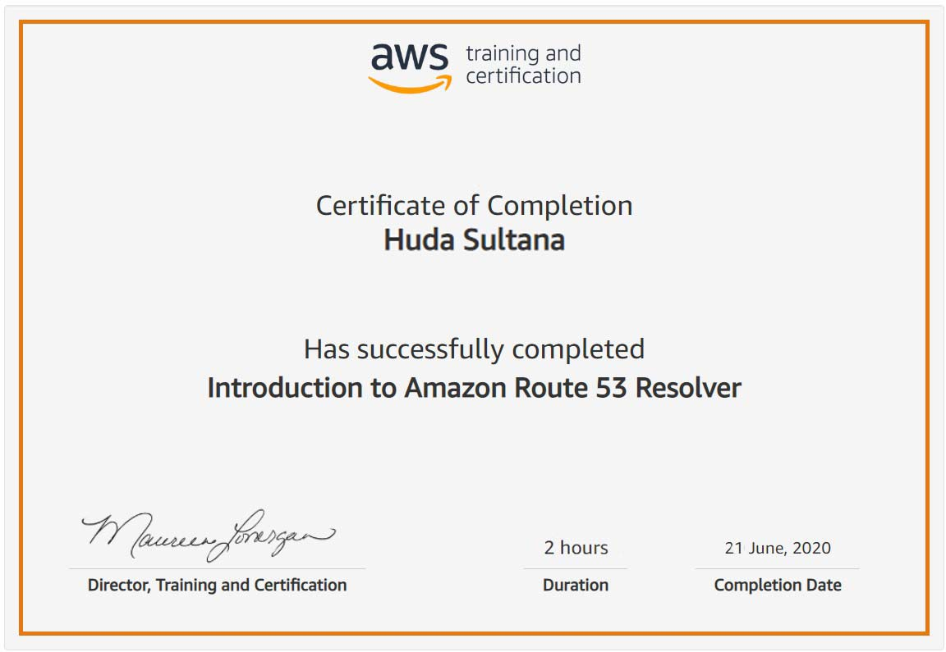

Coding Challenges Details:

**PROGRAM 1 .**

**//Write a C Program to rotate an array by K positions.**

**#include <stdio.h>**

**void leftRotatebyOne(int arr[], int n);**

**void leftRotate(int arr[], int d, int n)**

**{**

**int i;**

**for (i = 0; i < d; i++)**

**leftRotatebyOne(arr, n);**

**}**

**void leftRotatebyOne(int arr[], int n)**

**{**

**int temp = arr[0], i;**

**for (i = 0; i < n - 1; i++)**

**arr[i] = arr[i + 1];**

**arr[i] = temp;**

**}**

**void printArray(int arr[], int n)**

**{**

**int i;**

**for (i = 0; i < n; i++)**

**printf("%d ", arr[i]);**

**}**

**int main()**

**{**

**int arr[] = { 1, 2, 3, 4, 5, 6, 7 };**

**leftRotate(arr, 2, 7);**

**printArray(arr, 7);**

**return 0;**

**}**